**Kingdom of Saudi Arabia Ministry of education**  **Onaizah Colleges** **College of Engineering and IT** **Cybersecurity Dep.**



**المملكة العربية السعودية**

**وزارة التعليم**

**كليات عنيزة الأهلية**

**كلية الهندسة وتقنية المعلومات**

**قسم الامن السبراني**

----------------------------------------------------------------------------------------------------------------------------------------------------------------

Website Bloom Boutique Report

By Danyiah Almutairy ,Razan Alharbi

ID : 432210825 , 441210321

Course: Web Application development

Teacher: Tamader Al khalifah

1. **Introduction**

This project is an online flower shop website called Bloom, crafted with the vision of creating a captivating and memorable shopping experience for users. Bloom is more than just a platform for purchasing flowers—it’s a celebration of thoughtful gifting, beauty, and elegance. Every aspect of the site is designed to evoke a sense of aesthetic pleasure and uniqueness, ensuring that every visitor feels welcomed and engaged from the moment they arrive.

The primary goal of Bloom is to blend form with function. The design is not only visually appealing but also intuitive and user-friendly, making it easy for customers to explore a wide range of products. Whether users are searching for flowers, bouquets, or exclusive perfumes, they can effortlessly add items to their cart and proceed through a smooth checkout process. With features like real-time cart updates and a seamless payment process, Bloom offers a hassle-free shopping experience.

Bloom aims to connect with users emotionally, using design elements and interactivity to enhance their experience. From beautifully arranged bouquets to one-of-a-kind perfumes, each detail is crafted to help customers express their sentiments elegantly, making the gift-giving process as delightful as the gifts themselves.

1. **Tools Used**

• **HTML:** The backbone of Bloom, HTML was used to create and structure the website’s pages in an organized and logical manner. It serves as the foundation for all elements, from navigation menus to product listings, ensuring that users can easily explore the site.

• **CSS:** The creative tool behind Bloom’s visual appeal. CSS brings the site to life with carefully selected colors, elegant fonts, and harmonious layouts. Advanced techniques like Grid and Flexbox were employed to create a responsive, polished design that adapts beautifully across different devices and screen sizes, offering users a visually delightful experience.

• **JavaScript:** The core of interactivity on Bloom. JavaScript was used to add dynamic features like real-time cart updates, ensuring an engaging and intuitive shopping process. With JavaScript, Bloom becomes a lively and responsive environment where every action feels smooth and purposeful.

1. **Methodology**

The methodology for developing Bloom followed a structured approach to ensure the final product met user needs while maintaining high standards of design and functionality. Below are the steps and practices undertaken during the project:

**1. Planning**

• Objective Setting: Define the main goal of creating a user-friendly online flower shop.

• Requirements Gathering: Identify key features such as product categories, a customizable shopping experience, and a smooth checkout process.

• Wireframing: Create rough sketches to visualize the layout of the homepage, product pages, and checkout process.

2. **Design**

• UI/UX Design:

* Focused on creating an intuitive user interface (UI) for easy navigation.
* Used appealing color schemes and fonts to reflect the elegance of flowers.

• Responsive Design: Ensured the website was fully functional across different devices (desktop, tablet, and mobile).

• Tools Used: HTML for structure, CSS (with Grid and Flexbox) for layout and aesthetics.

3. **Development**

• Front-End Development:

* Created HTML pages for the homepage, product categories, and additional pages (About Us, Blog).
* Styled the pages with CSS, focusing on visual consistency and ease of use.
* Incorporated Flexbox and Grid for structured layouts and adaptive designs.

• Interactive Features:

* Added JavaScript functionality, such as real-time cart updates when products are added.
* Enabled smooth transitions between pages and a clear checkout process.

4. **Testing**

• Functionality Testing:

* Verified that buttons, links, and cart features worked as expected.
* Tested responsiveness across various screen sizes.

• Usability Testing:

o Gathered feedback from users to ensure the site was intuitive and easy to navigate.

5. **Deployment**

• Uploaded the website files to a web server, making the project accessible online.

• Conducted final checks to ensure all features and designs were correctly implemented.

1. **Website Components**

The Bloom website is structured around several key components that contribute to both functionality and visual appeal:

1. **Homepage (Home)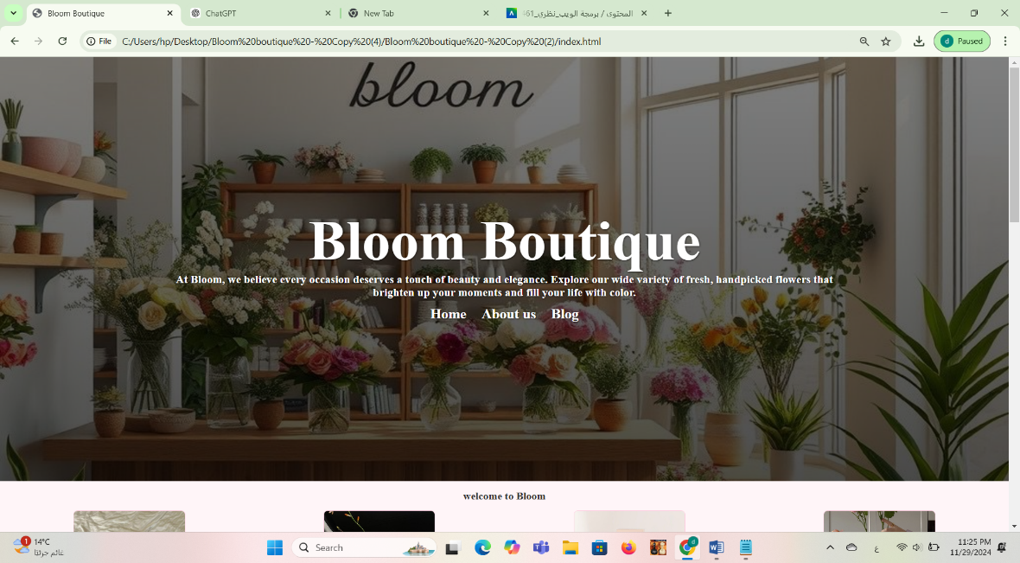:** The homepage features the website’s title and a brief introduction to the shop’s product categories. As users scroll down, they encounter different sections highlighting featured flowers and promotional discounts. The website’s header includes an AI-generated image of the shop, reflecting Bloom’s innovative and modern approach.

* 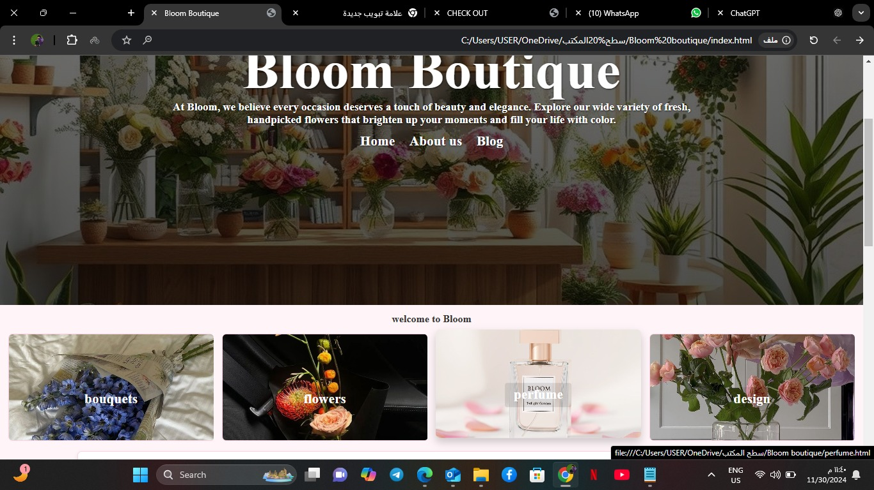**Product Categories:** In the homepage, as users scroll down, they will find different product sections. Clicking on any of these sections will redirect them to a new page with more information..
* 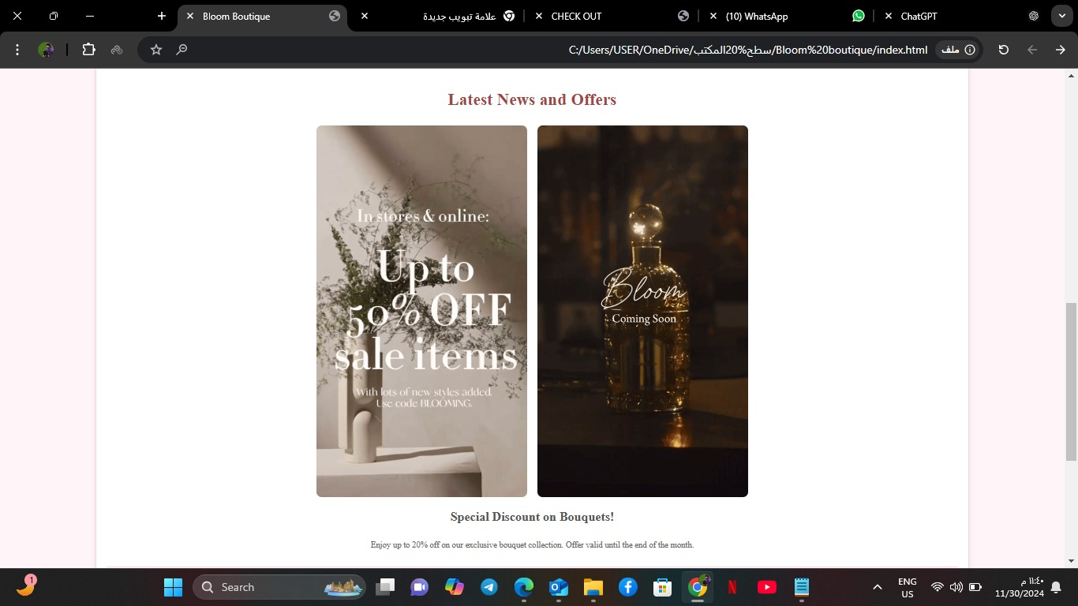**Offers section:** As users scroll down, they will come across the latest offers and products displayed at the bottom, along with an animated clip in GIF format..

• **Flowers**: A dedicated page displaying a variety of fresh flowers, carefully selected to suit different occasions.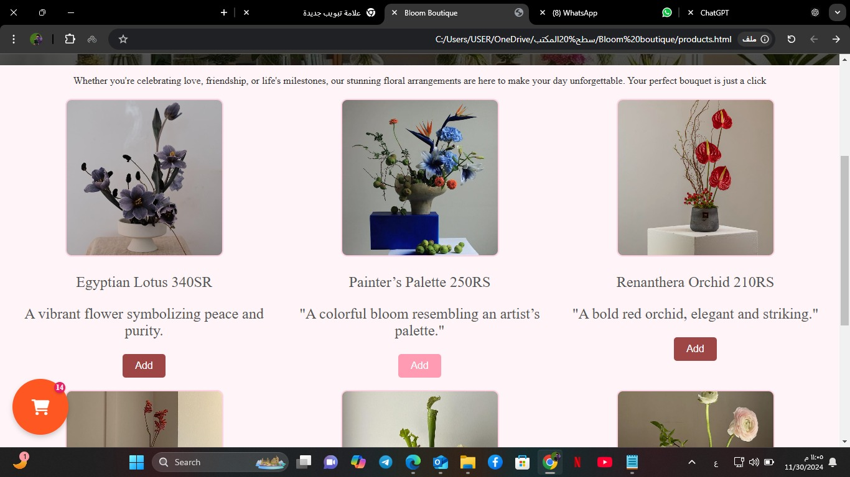

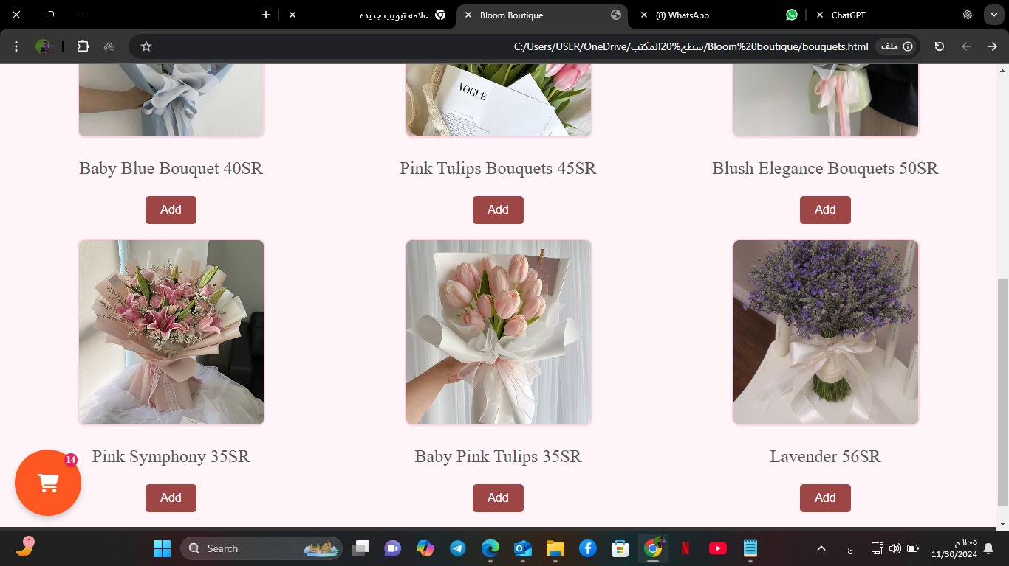• **Bouquets**: A page showcasing beautifully arranged bouquets, perfect for any special event.

• **Perfumes**: Bloom’s exclusive perfumes, designed using AI by the team, can only be found here, adding a unique touch to the shopping experience.

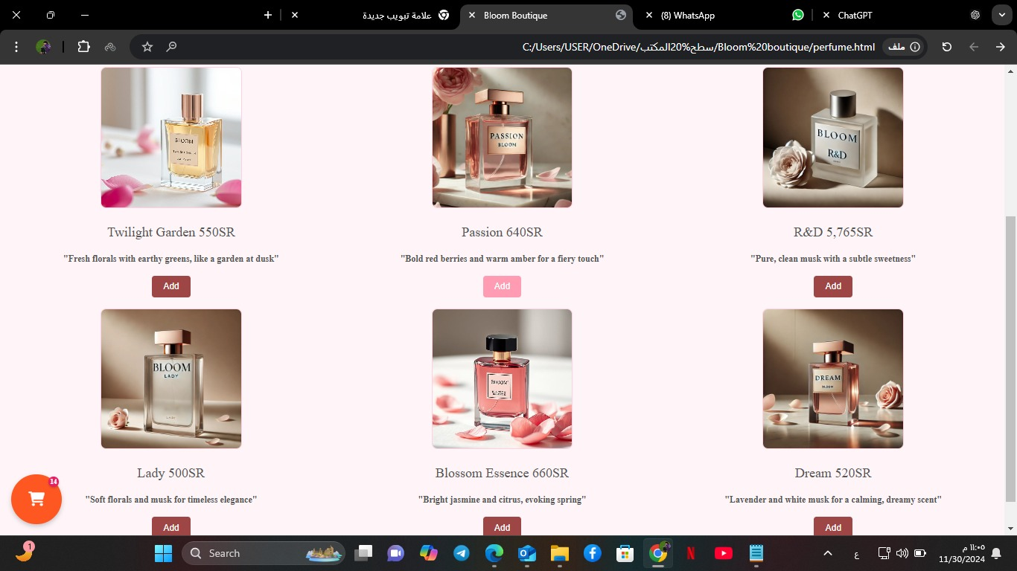

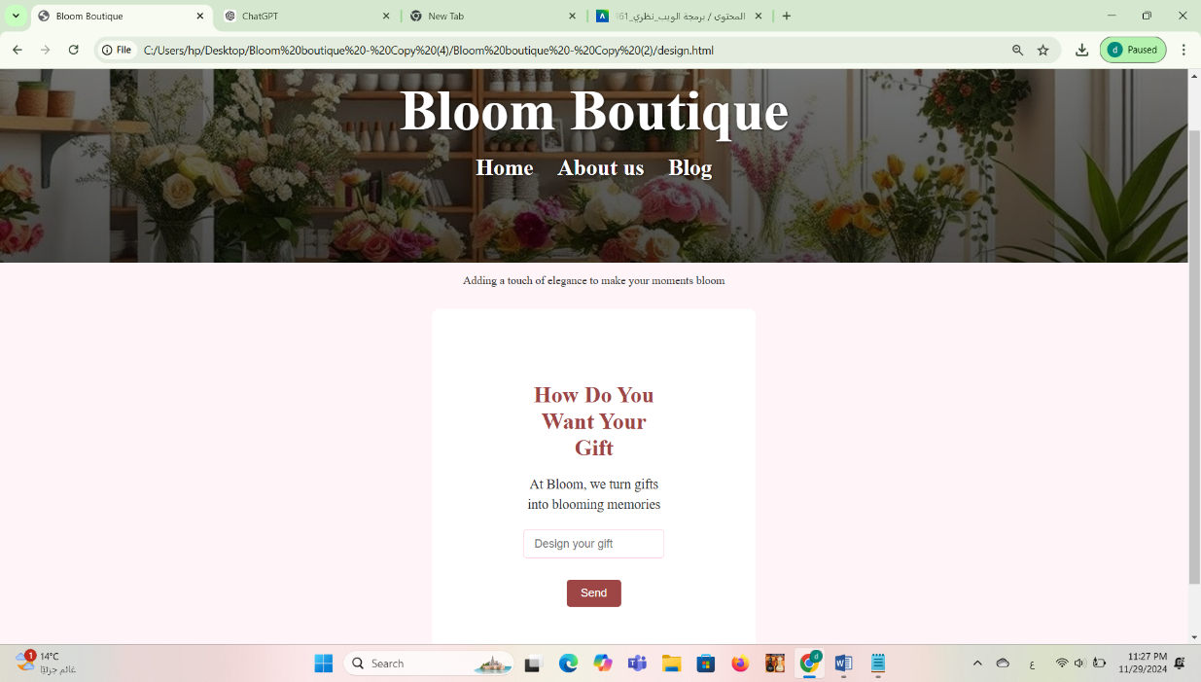**3. Design Your Gift Page:** This interactive page allows customers to personalize their gifts by selecting flowers, perfumes, or other items. The Bloom team ensures the final arrangement is crafted to meet the customer’s specific preferences, providing a unique and personalized shopping experience.

**4. Cart and Checkout Page :** As customers add products to their cart, the total number of items is displayed at the bottom of the page. The checkout page lists all selected items and payment options, ensuring a smooth and easy final step in the shopping process.

* 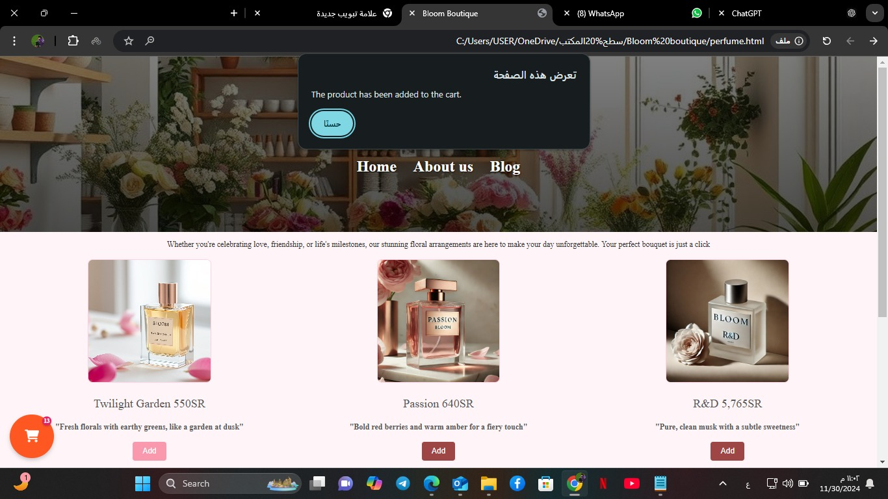**Adding the prouduct:**
* 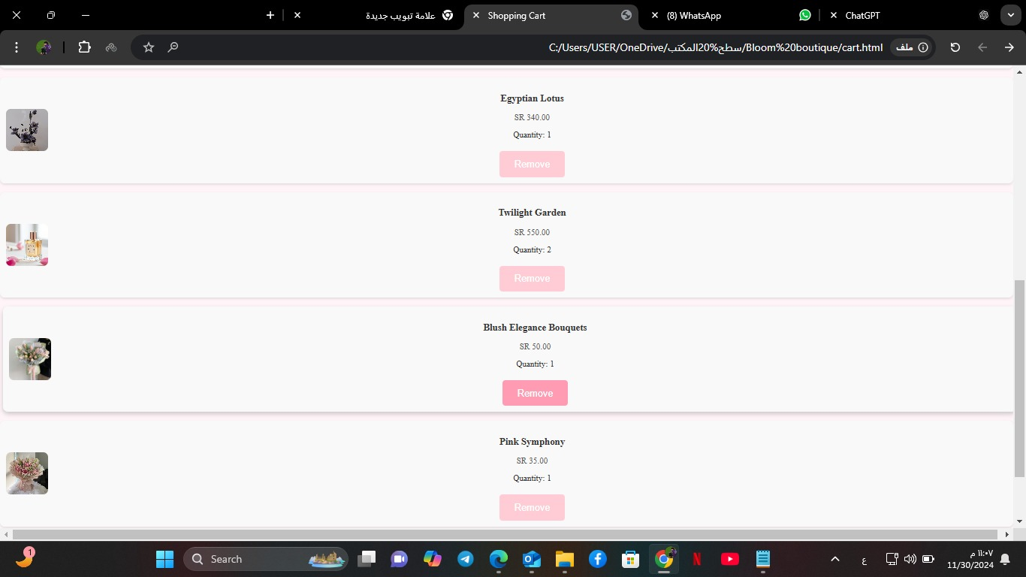 **The shopping cart :** When a product is added, it appears in the shopping cart along with the total order price. Users can easily add or remove products. Once the order is confirmed, clicking "Checkout" directs the user to the payment process
* 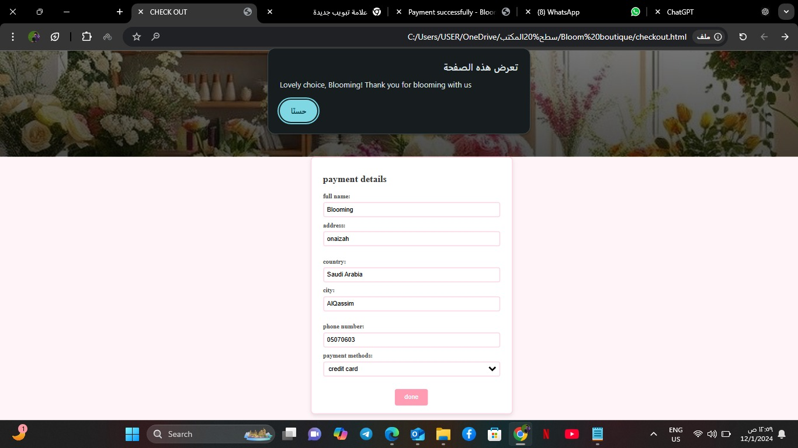**checking out :** After completing the payment information and verifying it, the order is submitted, and the user is redirected to the order confirmation page.
* **Alert Box:**  we added the alert box on this page to validate the fields:

### Field Validation Alert:Ensures all required fields are filled, reducing errors fr

### om incomplete input.

### Phone Number Validation Alert: Checks phone format with regex, improving data accuracy and user experience.

* 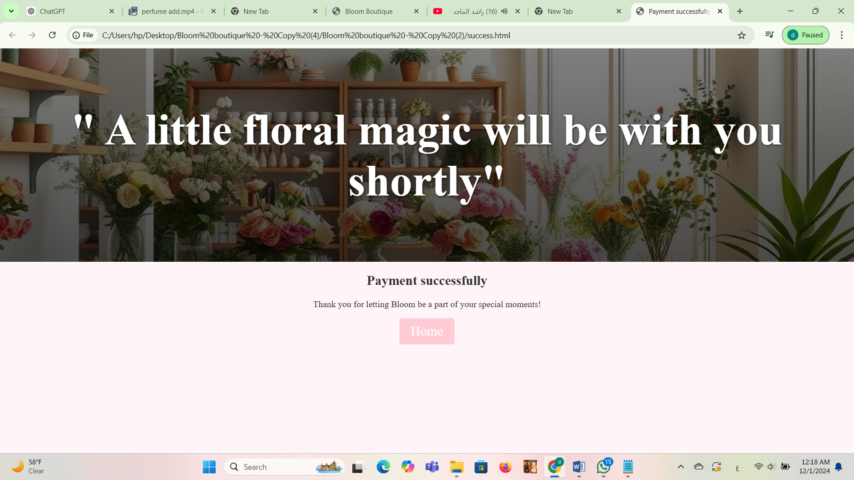**success payment:** This page displays the successful completion of the process and confirms that the order has been submitted. It includes a button to return to the homepage, allowing the user to explore new products and updates.

**5. Additional Pages**

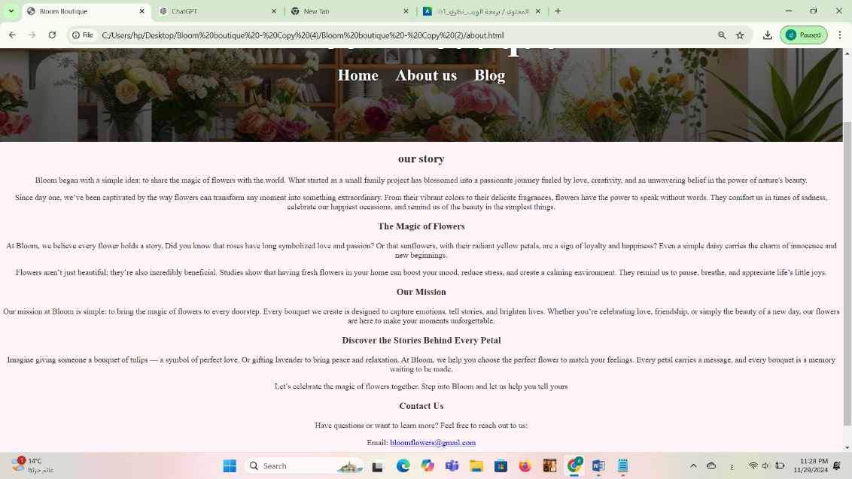• **About Us**: A page explaining the mission of Bloom and its commitment to quality and creativity, and contact information

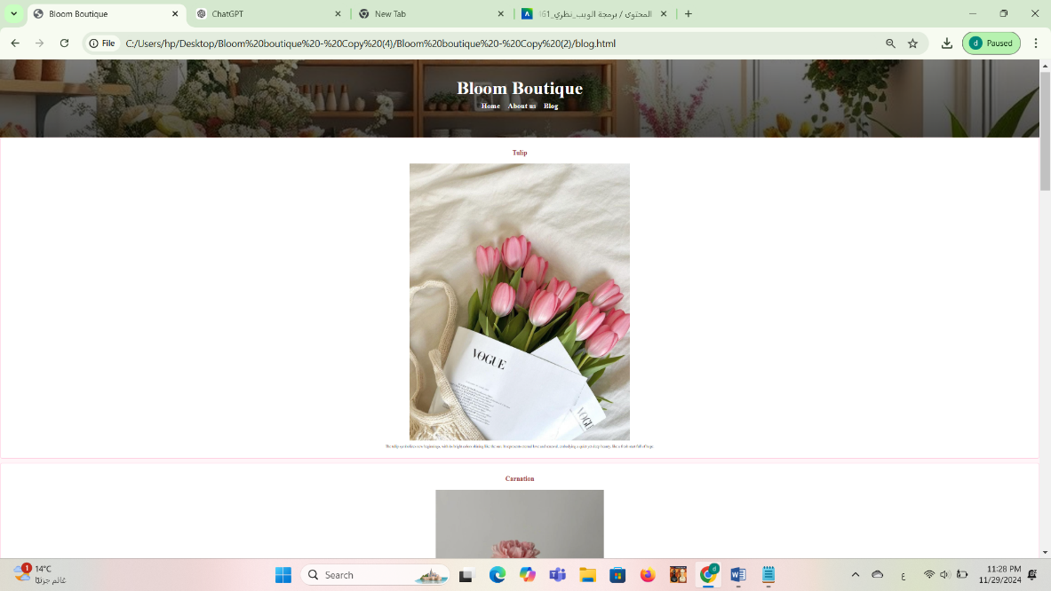**• Blog**: Contains helpful tips on flower care, floral arrangement ideas, and other insightful articles.

1. **Study Case**

**How We Benefited from Lavern in My Project**

While developing the **Bloom website**, We found the structure and design choices made by **Lavern** to be highly influential in shaping my own approach. One of the key lessons we learned from Lavern was the importance of responsive design. By closely analyzing how Lavern’s website adapts seamlessly to various devices and screen sizes, We ensured that Bloom’s layout was equally fluid, providing a smooth and user-friendly experience whether accessed on a desktop or mobile device. This responsiveness is crucial for retaining users across different platforms, and it allowed me to create an engaging experience for Bloom’s visitors.

Another aspect of Lavern’s design that impacted Bloom was the clarity and usability of the navigation menus and call-to-action buttons. Observing how Lavern effectively utilized simple, intuitive navigation made it clear that clear menus and strategically placed CTAs are key to a seamless user experience. We applied this lesson to Bloom, ensuring the navigation was easy to follow and the calls-to-action were prominently featured, guiding users effortlessly through the site.

The consistency in visual elements, such as color schemes and typography, was another important takeaway from Lavern. Lavern’s design maintained a strong, unified brand image throughout the website, which inspired me to align Bloom’s visual elements with the theme of elegance and beauty. By selecting a cohesive color palette and fonts that reflect the brand’s identity, We ensured that Bloom’s aesthetics were consistent and polished, contributing to a more professional and appealing user interface.

Lavern also taught me how to effectively draw attention to important content and features. By analyzing Lavern’s approach to highlighting product offerings and calls to action, We was able to implement similar strategies in Bloom. The design elements in Bloom were arranged in a way that ensures key features stand out, guiding users to important areas like the product catalog and checkout options.

When it came to performance, Lavern’s website was optimized for fast loading times, which had a significant impact on Bloom’s development. We learned the importance of minimizing load times to ensure a smooth browsing experience for users. By applying techniques such as image compression and efficient coding practices, We was able to ensure that Bloom loaded quickly and performed well under different conditions.

On the back-end side, Lavern’s use of robust programming languages like PHP and JavaScript influenced the choices We made for Bloom’s functionality. We adopted similar technologies to create dynamic features and ensure that the website was responsive and scalable. One of the key lessons was the scalability of Lavern’s database, which was designed to handle increasing amounts of data without compromising performance. We implemented similar practices in Bloom, creating a database that could scale as the site grows and more data is generated over time.

Additionally, Lavern’s API design and documentation served as an excellent model for me when creating the back-end structure of Bloom. We ensured that the APIs used in Bloom were well-documented and easy for third-party developers to work with, allowing for smoother integrations in the future. Lavern’s attention to security was another lesson We took seriously. By studying their security protocols, We made sure that Bloom was built with robust security features, including data encryption and vulnerability testing, to protect user data and prevent potential attacks.

Finally, Lavern’s performance stability was something We prioritized for Bloom. We recognized the importance of a site that loads efficiently and does not experience frequent crashes. By following the performance optimization practices We observed on Lavern’s site, We ensured that Bloom would provide a reliable and stable experience for its users, free from significant errors or slowdowns.

In conclusion, Lavern’s best practices and thoughtful design choices played a crucial role in the development of Bloom. From responsive design and navigation to performance optimization and security, the insights We gained from Lavern helped me create a more user-friendly, visually appealing, and technically efficient website. These lessons not only improved Bloom’s functionality but also ensured that the site would grow and scale to meet future needs, just as Lavern had successfully done with its own platform.

1. **Final Outcome**

The Bloom project successfully achieved its goal of creating a simple yet visually appealing website that offers an engaging and intuitive shopping experience. The website includes:

• A Diverse Range of Products: From fresh flowers and beautifully arranged bouquets to exclusive perfumes, Bloom offers a variety of items that cater to different needs and preferences.

• A Customizable Shopping Experience: The “Design Your Gift” page allows customers to personalize their purchases, ensuring a unique and memorable gift every time.

• A Seamless Shopping Process: Real-time cart updates, smooth transitions between pages, and an easy checkout process make the experience hassle-free.

• An Emotional Connection: By incorporating AI into the design of exclusive perfumes and using AI-generated images, Bloom creates an emotional connection with customers, enhancing their shopping journey.

1. **Conclusion**

Bloom is more than just an online flower shop; it is a celebratory journey of beauty, innovation, and the joy of gifting. The methodology we followed in developing the website was carefully crafted to ensure that every detail contributed to delivering a unique and seamless shopping experience. By blending elegant design with modern technologies focused on user experience, Bloom has become the perfect destination not only for finding flowers but also for discovering an emotionally engaging and visually pleasing experience. Every element of the website reflects the Bloom team’s dedication to creating a shopping environment that is simple, beautiful, and innovative, ensuring that every visit will be an unforgettable experience that exceeds expectations.

1. **References**

• **Lavern Website**: Analysis of Lavern’s design, highlighting responsive layouts, intuitive navigation, and effective call-to-action elements.

• Marcotte, E. (2010). Responsive Web Design. A List Apart. Discusses principles for creating adaptable websites that work across various screen sizes.

• Frain, B. (2015). Responsive Web Design with HTML5 and CSS3. Packt Publishing. Offers practical techniques for responsive web development using HTML5 and CSS3.

• Norman, D. A. (2013). The Design of Everyday Things. Basic Books. Focuses on intuitive navigation and usability principles for enhancing user experience.

• Resig, J., & Bibeault, B. (2013). Secrets of the JavaScript Ninja. Manning Publications. Advanced techniques for building responsive and engaging web applications.

• Souders, S. (2010). High-Performance Web Sites: Essential Knowledge for Front-End Engineers. O'Reilly Media. Discusses methods for improving site performance and reducing load times.

• Chaffey, D. (2019). Digital Marketing: Strategy, Implementation, and Practice. Pearson Education. Provides strategies to enhance user engagement on e-commerce platforms.

• Laudon, K. C., & Traver, C. G. (2020). E-Commerce 2020: Business, Technology, Society. Pearson Education. Offers insights into e-commerce technologies and user-centric design.

• OWASP. (2017). OWASP Top Ten. Open Web Application Security Project. Key resource for securing web applications against common vulnerabilities.

• Haenlein, M., & Kaplan, A. M. (2019). A Brief History of Artificial Intelligence: On the Past, Present, and Future of AI. California Management Review. Examines AI's role in product and design innovation.